Chapter 14, Solution 47.

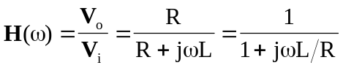

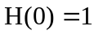 and 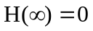 showing that this circuit is a lowpass filter.
At the corner frequency, 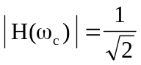, i.e.
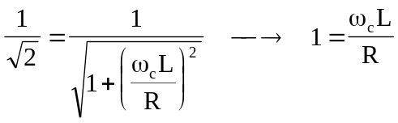 or 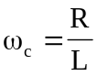

Hence,
